Dyslexia and Inclusive Practice – GTCS Professional Recognition Programme

Application Criteria Outline: 2024-2025

Dyslexia Scotland is seeking applications from teaching professionals who have completed a minimum of one year of professional practice after gaining full registration from GTC Scotland and who have then gone on to engage in sustained, significant professional learning in Dyslexia and inclusive practice. This learning must include the completion of the Open University Dyslexia and Inclusive Practice Modules 1 and 2.

Support for Learning teachers, Additional Support Needs teachers, Pupil Support teachers and local authority Inclusion Education Officers are encouraged to apply, as well as others such as classroom teachers and Principal teachers who are able to work in partnership with their support teachers.

The fourth year of our exciting GTCS Professional Recognition programme will start in September 2024 and end in August 2025. The programme was accredited by the GTCS in June 2021.

The aim of the programme is to develop accomplished expert teachers in dyslexia and inclusive practice so that they are well equipped to support learners and colleagues through the holistic identification and support process for dyslexia in Scotland. Closing date for applications: midnight on 24 May 2024.

Background

Working in partnership with Education Scotland, we developed the Dyslexia and Inclusive Practice Professional Recognition Programme following an extended pilot that took place from 2017-2019. We built on the learning of the pilot through active engagement with the participants; therefore, the programme is grounded on their feedback, the impact of the professional learning on teachers and the learning of the programme tutors as a collaborative team. The GTCS accreditation panel commended the inclusion of children and young people in the development of the programme.

The programme:

- Is a creditable and effective way to deepen Scottish teachers’ knowledge, understanding and practice to support learners
- Meets a need within our educational system, builds capacity and creates a free sustainable route to high quality professional learning, to increase the number of GTCS registered teachers with dyslexia and inclusive practice professional recognition.

What are the criteria for applicants to join this programme?

Candidates are required to submit a personal statement which must include the following:
- Their GTCS registration number and date of full registration
- Why they want to engage in the programme; what would they contribute?
- A summary of any relevant qualifications (accredited or non-accredited) or professional learning they have engaged in over the last 5 years
- How they support professional learning within the school community, for example leading in-service/collegiate sessions with colleagues
- How they plan to take the learning forward at each stage of the programme in their area
- Open University Dyslexia and inclusive practice Modules 1 and 2 badges
- Written permission from their head of establishment/local authority
- Any other relevant information in support of their application

Programme of study

The programme is expected to take at least 65 hours, which includes:

- Three Saturday Masterclasses (see Programme dates below)
- Participants are expected to carry out intersessional study, practitioner enquiry and collaboration with peer learners between each masterclass, as set out below
- Participants’ own study: online Open University Dyslexia and inclusive practice Module 3. (See more details about the Modules in Appendix One). When doing the modules, learners are encouraged to use a Reflective Log as they work through the coursework; what they write in this Log forms is an important part of the learning process. They are advised to revisit the Log regularly and use the information in it as evidence of their professional development, reflective practice and critical self-evaluation, all which contribute towards their GTC Scotland professional update.
- Practitioner enquiry, involving personal reflection as well as collaboration with colleagues and their school community; this is linked to Module 3, on the broad topic of dyslexia and inclusive practice, with individual areas of research to be agreed and explored as part of the programme discussions.
- GLOW Team space for sharing ideas and practice
- Optional monthly online Drop-in twilight sessions through the year
- One Saturday Professional Recognition Reflective Support Day
- Submission of Professional Recognition application
- Professional Reading and additional research papers are shared during the programme.

Application timeline

- Closing date for applicants: midnight on 24 May 2024
- Shortlisting panel to review applications: 28 May -11 June 2024
- Shortlisting panel meeting: Wednesday 12 June 2024
- Inform applicants whether successful or not: by 21 June 2024

Programme dates

Masterclass One: Saturday 31 August 2024 (in person, Stirling)
Masterclass Two: Saturday 18 January 2025 (online)
Masterclass Three: Saturday 26 April 2025 (online)
Monthly online Drop-in twilight sessions (optional – dates provided if successful)
Professional Recognition Reflective Support Day: Saturday 24 May 2025
(in person, Stirling)
Submission of applications: no later than 10 August 2025

Appendix One – Dyslexia and inclusive practice online modules

Overview of the three Dyslexia and inclusive practice modules

The three professional learning Dyslexia and inclusive practice modules are intrinsic to the learning outcomes for this programme. After studying the three modules, engaging in the tasks and carrying out their practitioner enquiry, participants will have a deeper knowledge, understanding and experience of the following:

- Dyslexia and inclusive practice within the Scottish context of education
- Equality and equity
- Dyslexia research
- Appropriate and collaborative support and assessment of dyslexia within the Scottish context
- Effective leadership and collaboration to support school communities to improve the outcomes of learners with dyslexia and associated difficulties.

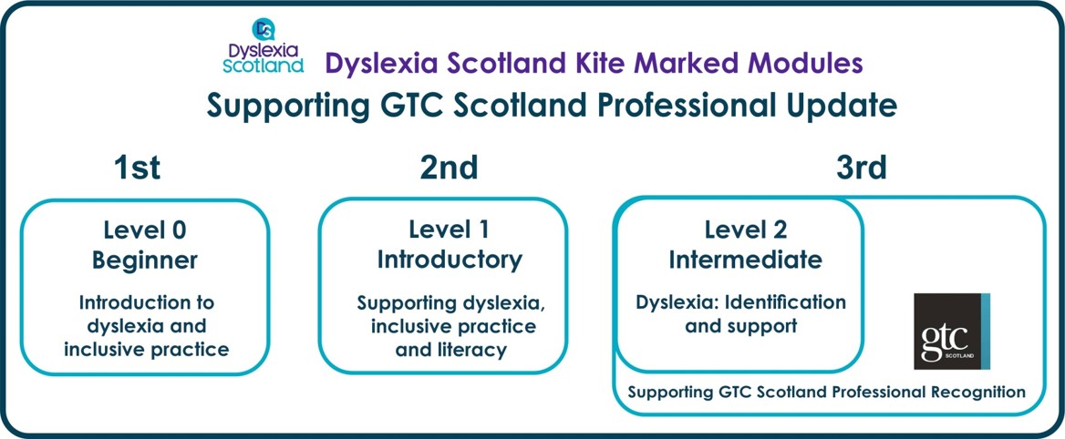

The three online modules were developed collaboratively by Dyslexia Scotland, Education Scotland, the Addressing Dyslexia Toolkit working group and the Scottish Government, with the Open University in Scotland.

Developed and structured around the GTCS CLPL standards (and updated in line with the 2021 Standards), the incremental modules support reflective conversations, annual reviews and professional updates, which can contribute towards an application for GTCS Professional Recognition.

Module 1: ‘Introduction to Dyslexia and Inclusive Practice’
Module 2: 'Supporting Dyslexia, Inclusive Practice and Literacy'
Module 3: 'Dyslexia: Identification and Support'

