Report on:
The 2023 Survey of Scottish Qualifications Authority (SQA) exam support and school learning support for dyslexic pupils
By Vivien Clarke, AMBDA, Dyslexia Scotland, Specialist Dyslexia Tutor with family incidence of dyslexia

The Survey
The 2023 version of my survey for Parents/Carers of a dyslexic young person who had undertaken SQA Exams at school in April/May followed a similar survey in 2022. The 2023 survey was delivered on the Survey Monkey hosting site between mid-June and the end of August by Dyslexia Scotland. My thanks go to Dyslexia Scotland staff who were most helpful in supporting and promoting access to the survey via their website and social media. Thanks also to Hazel McPake, who helped with analysis of results, and my son-in-law, Ryan Mathers for help with bar charts. Thanks most of all to those who took time to respond to the survey!
The instructions were: “1 survey per young person – to be completed by parent/carer, alongside the young person if wished. If you have more than one young person, please complete a separate survey form for each.”
A Word version of the survey is available at the end of this report.

Reason for Survey
As a specialist dyslexia tutor, I had been hearing from parents about poor support in secondary schools and SQA exams. I wanted to consult with a wider group across all parts of Scotland. With more evidence, it may be possible to raise the level of support for learning in general, and in SQA exams.
I am also interested in following up the findings by extending training opportunities for parents and teachers on the topic.
School staff have had an incredibly hard time in the last few years and will continue to have many pressures upon them. Additional teacher training on support for specific learning difficulties would be very welcome but I also believe that many parents would like to know more to become “effective stakeholders” in the Scottish “Empowered” System.
https://education.gov.scot/improvement/learning-resources/an-empowered-system
Many of the parent comments show that support arrangements only happened because of parental action.

The roles of the SQA and of schools
The SQA are only in charge of our exam/qualifications system in Scotland. When the school system, historically, has decided to teach a new subject, e.g. business management, Education Scotland would develop a curriculum and, closely-linked to that, SQA would develop exams to assess what pupils have learned.
Since disability rights have been well recognised in the UK, the SQA has created a system of Assessment Arrangements (AAs) to support all pupils and students to achieve qualifications despite disability or learning difficulties. Naturally, SQA had to devise guidance and rules to ensure that qualifications would be equally meaningful to further education and employers regardless of the support needs of the candidate.
Most school pupils will sit their first SQA exams towards the end of their S4 year. At the start of that school year, staff will start the onerous task of setting up separate AAs for individual pupils, in each of their examination subjects, in each year of study.
There will normally have been 10 years of school education preceding this. SQA do not set out to tell teachers how to support pupils in those 10 years but Education Scotland has no list of support suggestions that I know of to compare with the list of AAs on the SQA website. What SQA does is point out that support in exams should ideally be the “normal way of working and showing learning in the classroom”. In other words, if an AA of reading support is being requested in an exam, that should be because a pupil has been learning and doing class work with that support. This is why both parents and teachers would ideally know about SQA AAs so that support which can take students all the way can be in place as early as possible.

There were 127 responses to the 2023 survey. Pupils sat the following exam levels in 2023 –
Nat5 | H and Nat5 | H only | H and Adv H | Nat5, H & Adv H | Adv H only
67 | 18 | 37 | 2 | 2 | 1

In May of 2023, all students were in S4, 5 or 6. 123 students had been in the same secondary school since S1, 3 for around the last 2 years and 1 for 1 year or less.
Whilst all 127 responses were about students with dyslexia, only 90 of those had a written statement/report saying they had been found to be dyslexic. Of the 90 who did, 17 of those had obtained a report privately and the other 73 from their school.
Many school assessments were done at primary (49). Primary schools are obliged to pass on information to secondary schools at transition. Secondary schools need to have evidence of dyslexia to satisfy the SQA’s Quality Assurance System that this is the reason for requesting AAs. Beyond school, there may be times when evidence of dyslexia is required so it is not in the student’s interest or the school’s interest that no written evidence is provided. Parents may feel dismayed, as it is often due to their persistence that the dyslexia pathway is started and it may have taken a year and a half to complete. This is not the way to treat “important stakeholders” in the outcomes of young people!
Parent comments on having dyslexia assessed:
“After 5 years of asking for an assessment.”
“Late primary - P7, despite lots of previous flags and us raising concerns.”
“We had asked at every Primary parents’ evening about X’s reading and writing abilities. We were told that he was doing fine.”

Proposal 1 For Education Scotland, Local Authorities, Independent Schools

Every pupil in Scotland who has been on a “dyslexia pathway”, whether in primary, secondary or private school, must have at least a summary report of the route taken and the conclusions made as to whether a pupil has a support need (dyslexia) or not.
Support Plans

Once at secondary school, pupils with a dyslexia assessment should have a support plan. Parents were asked “Did the student have a support plan describing support for learning made available to all teachers?” Only 62 out of 127 reported positively. Many of them may have remained static in secondary school, still reading in S4 as they did at transition and many teachers may have been unaware of their existence. Support plans are kept digitally and teachers must seek them out. Many parents have reported that when they speak to teachers at parents’ meetings, teachers are often unaware of the student’s dyslexia or support plan.
Parents were further asked if the support plan had been reviewed and if they had been involved in that. Some responses:-
“A review each term.”
“I had to be very proactive and make requests for specific support. Bit of a fight to get the desired result.”
“Not really (reviewed) but comments listened to and something actioned.”
“We had the diagnosis after the Prelims, so plans were put in place and amended up to the exams in May.”
“No but discussed at parents evening when have a meeting with SFL.”
“After my son and his learning support teacher discuss and agree it, the plan is sent to us for comment every year.”
“We (parents) asked for review after prelims as daughter did not seem to get access to support with reading or spell check. Only access to digital paper.”
“Not officially reviewed but other support added in as other diagnosis of ADHD was given.”
“The school carried out a review with my child and then shared it via email to the parents.”
“Reviewed with child and teacher. Although CAMHS info was included and updated.”
“After phoning the school.”
“I was driving the school, explaining my child’s needs.”
“Yes, because I phone/email to make sure it’s done every year.”
“Not really consulted by school. Had to make contact on numerous occasions and finally was able to arrange a meeting with guidance and support for learning. Communication with school was not good.”

Proposal 2 For Education Scotland, Inspectorate, Local Authorities, School Management

Subject teachers to be required to report on support used (or not) in class as part of existing reporting. Reporting on pupils with support needs without any mention of support provided (or not) raises more questions for parents than it answers.

Proposal 3 For School Management

Support reviews to be carried out annually with a student and a parent/carer plus supporter if wished. The parent/carer could be on a link/phone if unable to attend.
Even at 16, students are still very vulnerable to peer pressure. They do not want to seem to be different, weaker or less intelligent. They may not fully comprehend the difference qualifications may make to the rest of their lives and they really should have an advocate. Asking parents to comment after the meeting is very different from including parents as equal partners in the discussion.

In S4-6, reviews of support requirements are connected to the final arrangements for the AAs the student will use in SQA exams. The “consent letter”, referred to below in relation to Maths, requires a signature for consent to send SQA the AA details and the disability/learning difficulty of the student. Understandably, schools are buckling under the ever-increasing workload pressure of setting up AAs and some are now asking school students to sign the letter and then send a copy to the parents. Currently, only the oldest Scottish students will turn 16 at around the time these letters will go out (Feb/April before the Nat 5 May exams. This is simply another issue parents would benefit from being aware of in advance so that they will have had relevant family discussions.

Pupil Challenges

Parents were asked to list the educational challenges faced by their student with dyslexia. The bar chart shows the results.

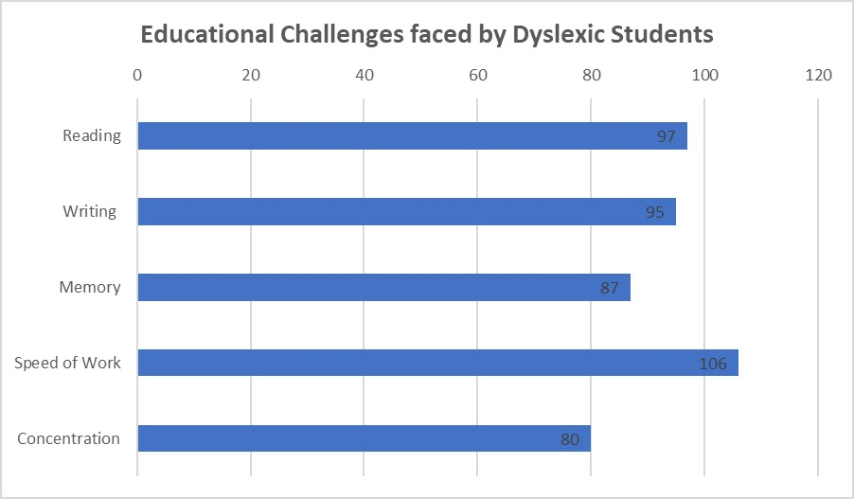

Parents were then asked the following question.

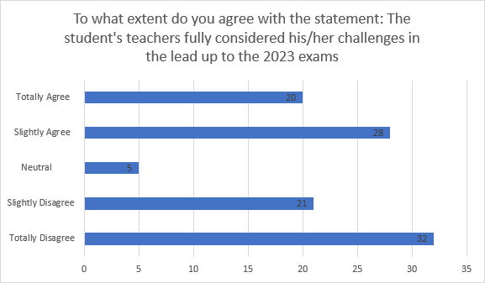

When the same question was asked last year, the number of parents in agreement was more than double the number who disagreed. Parents’ comments below show why there was more negativity this year.
“The communication from learning support, which started soon after diagnosis has been fantastic. There has been barely any communication from individual teachers unfortunately.”
“As parents, we had to initiate all communication with school staff about support for the exams.”
“Some teachers didn't realise he has dyslexia until the March parents’ evenings. Noticed he was given extra time in some but not all exams. When I asked about this, the response was that the teachers didn't know how to request it.”
“A lot of teachers don't get told about a child's dyslexia. Some teachers don't do anything to support child and some teachers don't teach child how they need to be and get annoyed when they ask for extra support or notes which they missed ‘cause teacher going too fast. Which results in child losing confidence asking teacher for help and affects their learning.”
“Teachers individually knew she was slow to complete work but until in person parents meeting it was never vocalised. It was then the real pattern emerged, just weeks before the Highers!”
“Even though support plan in place and numerous meetings initiated by parent - plan and advice not followed by school - absolutely disgusted with the education my son has had.”

Maths support
Returning to the bar chart of pupil challenges as understood by parents, 87 students were deemed to have a challenge with “memory, e.g. for mental arithmetic”. Parents who can, usually try to support children to practise times tables and would be aware of their level of difficulty. With dyslexia, often when one table is mastered, the previously learned table facts are forgotten!
Support in primary school for poor memory might start with a tables square and, in high school, move on to use of a calculator.
Following my report on the 2022 survey, in November, I asked SQA to re-word Numerical Support as it was suggesting that this could only be requested for pupils with dyscalculia. Staff at SQA stated that Assessment Arrangements in Scotland are “needs-led” and agreed to re-word Numerical Support to make that clearer but did not update “Assessment Arrangements Explained” till August 2023.
The version of the first paragraph till Aug 2023 - (bold words highlight where changes were made)
“Candidates appropriately identified as having a specific disability in number manipulation/calculation/retention (dyscalculia), could be permitted, as a reasonable adjustment, to use a number square/line, multiplication square or a basic calculator in non-calculator mathematics assessments.”
New version of the first paragraph in Aug 2023 -
“Learners appropriately identified as having a specific difficulty with number manipulation/calculation/retention (for example, dyscalculia, although this does not need to be formally diagnosed) could be permitted, as a reasonable adjustment, to use a number square/line, multiplication square or a basic calculator in non-calculator mathematics assessments.”
The new version of the first paragraph still suggests that students must be thought to have dyscalculia to have this AA.
It states the student does not have to be “formally diagnosed” but does have to be “appropriately identified”. How are staff or parents to understand this?
The rest of the descriptor continues:-
“Note: The calculator must be a basic, four-function calculator, capable of basic multiplication, division, addition and subtraction only — no other function is allowed.
Para 2. The provision of this type of basic numerical support is permitted as a reasonable adjustment for disabled learners to remove their substantial disadvantage and allow them to demonstrate their attainment of the required mathematical operational and reasoning skills.
Para 3. It is generally accepted that a learner who is diagnosed with a numeric difficulty such as dyscalculia may be characterised by difficulties in processing number concepts and mastering basic numeracy skills. It often occurs alongside other specific learning difficulties such as dyslexia, but it is important to note that not all dyslexic learners have problems with numbers. This is why we require centres to have appropriate evidence that a learner has been identified as having a particular disability/specific difficulty with numbers and is placed at a substantial disadvantage in demonstrating their attainment because of this particular disability/difficulty.
Para 4. For example, a learner’s specific difficulty with numbers must be appropriately identified. You must have evidence that the learner’s identified level of difficulty means they require appropriate numerical support, and is not caused by a lack of ability, prior knowledge or motivation.
Para 5. As with any request, the evidence would support the need for an appropriate assessment arrangement, which meets the individual learner’s needs and reflects classroom practice.
Note: Learners who use any form of numerical support should be encouraged to write all of their working, even if this is simply recording what they are entering into the calculator, to ensure they can access the full range of marks available for each question in the assessment.”
(Bold words are my highlighting.)
- - - - -
Paragraphs 2-5 of the AA script with their repetition of “disability/specific difficulty with numbers” and its overly medical language is still totally misleading. This AA was in place before the term “dyscalculia” was widely used. Two versions ago, the straightforward term “memory difficulties affecting maths” was part of the wording.
Support for learning in Scotland is provided on a “needs-led” basis and therefore support in maths should be available to those who have difficulty in retaining a speedy recall of tables and/or cannot remember the layout of long division compared to subtraction. For the largest number of Nat 5, Higher or Adv Higher students requiring an assessment arrangement in maths, memory difficulties such as these are the issue, as very few pupils identified with dyscalculia will be able to reach this stage.
Teachers should not be put off considering numerical support for dyslexic students. Many dyslexic students, when younger, have difficulty learning and retaining times tables, telling the time on analogue clocks and with the language of maths which can be very confusing for those who have trouble distinguishing between “left” and “right”.
A dyslexic profile often includes slow speed of processing. When a maths teacher is verbally teaching a sequential maths process, the listener must turn the sound of the words into meaningful ideas. When this takes longer than average, the listener can miss a few steps in the process through no fault of their own and be unable to understand that lesson.
Another common feature of dyslexia is a weakness in working memory. An example is holding a memory of the question, say 48 x 102, whilst working out the answer.
The British Dyslexia Association says “60% of individuals with dyslexia will have difficulties with maths”. https://www.bdadyslexia.org.uk/dyscalculia/how-can-i-identify-dyscalculia/how-does-dyslexia-affect-maths-learning
Looking back at the bar chart for “Challenges faced by Dyslexic Students”, you will see that 87 respondents considered “memory, e.g. for mental arithmetic” to be a challenge. Many of those students will be among the 60 who sat a Maths exam this year….only 8 of whom had been given Numerical Support in Maths as an AA in their exam!

Of those 8, only 3 were said to have used it as the normal way of learning and showing their work in the maths classroom! What an appalling waste of potential!

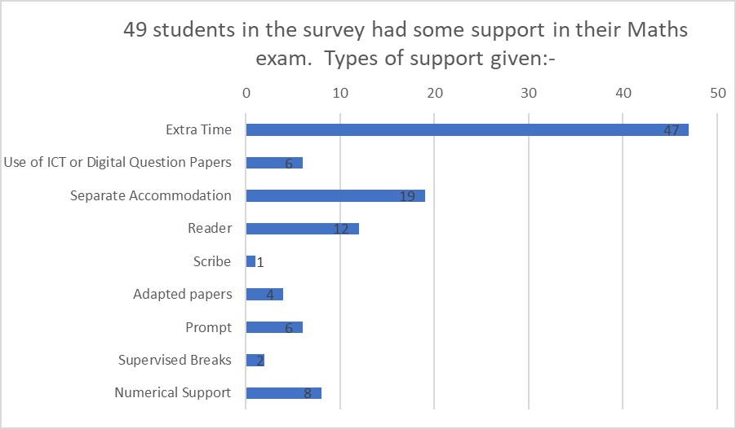

Parent Comments: (regarding practice in class of the AA used in the exam)
“No practice other than prelims. No support given at all in class for Maths either.”
“My daughter was tested for dyscalculia in late 2022. This was only because we had been able to get a maths tutor for her. He identified this as an issue after working with her for 6 weeks. The school had not picked this up. My daughter has had support for dyslexia from primary school but the secondary school did not pick up her dyscalculia.”
“I don't know (about classroom practice of Numerical Support) as she is only doing Nat 4 Maths now in S6 which she has only just started. Maths is the subject I find has least understanding from the teachers in this department at our school for children with additional needs.”
“No support in any way for maths or higher application of maths.”
“Really struggled with maths. Was put into Nat 5 class and could not cope. Was supposed to be put in a practical finance class but this was then not run by school. Had to be changed to level 5 Numeracy and had to work on this on own in N5 class.”
“We had to specifically request a calculator as parents. The school did not suggest/offer one.”
Proposal 4 For SQA
SQA must urgently look again at the wording of Numerical Support in Maths. This should be done with both experienced maths teachers and specialists in dyslexia and dyscalculia. The re-written descriptor must make it clear that some dyslexic pupils do have difficulties with maths within their dyslexia so that SQA centres can request Numerical Support for the reason they are dyslexic. Alternatively, a new “reason” could be added, for example “Memory Difficulties affecting Maths”.
(See some further explanation of this point a few paragraphs below)
Proposal 5 For Education Scotland, Local Authorities, secondary maths teachers
Teaching and learning in the high school classroom should incorporate both practice with and without a calculator for work which will crop up in the Non-Calculator Paper to allow pupils with specific memory difficulties to progress to Nat 5. Teacher observations could record which pupils can work more successfully at a suitable pace with a calculator. Their observations would provide the evidence for use of the AA and become a student’s “normal way of learning and showing work”.

On request, I provided SQA with sight of the raw response data of my 2022 Survey with no personal detail. In early autumn 2023 SQA have been running their own Surveys, one for parents/carers and another for learners and educators. This is all good, ahead of a new exam body and a new inspection body.
Their parent/carer survey was looking at many of the same things I have been looking at in both my surveys – which I am delighted to see. They are asking parents of a student who needs support if they have ever received information on how AAs work and if they have ever discussed the need for AAs for their young person.
They also ask if parents are happy with the arrangements for the “consent form”. This is a form a school sends to parents, listing the final AA choices to ensure they are still fully in agreement. A signature is required to show agreement and to allow the school to share “information” with SQA. SQA provides a template form for schools. I mention this here as I am not confident that parents will recognise the form being referred to as the “consent form”.
The “consent form” template does not mention that the “information” schools must send includes the reason why the student requires AAs. There is a drop-down list of reasons for AAs such as physical disability, hearing impairment, dyslexia, dyscalculia, etc.
There are two issues to point out.
- Sharing sensitive information with a third party which, in some cases, has not been shared with parents/pupil would seem entirely wrong.
- Whilst the SQA descriptor for Numerical Support in Maths is so unclear, school staff who are doing the best they can to support dyslexic candidates, may enter “dyscalculia” as the reason for support because they fear that “dyslexia” will not be acceptable! It is wrong that they should be made to consider that necessary. Hopefully, this point will encourage speedy action from SQA and Education Scotland Mathematics team on Proposals 4 and 5 above.

Proposal 6 For SQA presenting centre managers/SQA
Ensure all pupils supported in exams for reason of dyslexia have had a short report declaring that the school considered them to be dyslexic. Then make it clear on the “consent” letter (if SQA have not changed their template) that parents are being asked for permission to share both AA information and disability/learning difficulty information with SQA.

English – support in class and in exams.
Maths and English are the two subjects which are generally most valued by educationalists and employers. They are also the two in which support is often most needed for dyslexic students.
83 respondents reported the student had sat an English exam and 15 had not (29 blank). All 83 of those who had sat an English exam had used at least one AA and plenty used several. This is to be expected and it looks good for the exams but tells us nothing of support for learning in English…hence the question ….
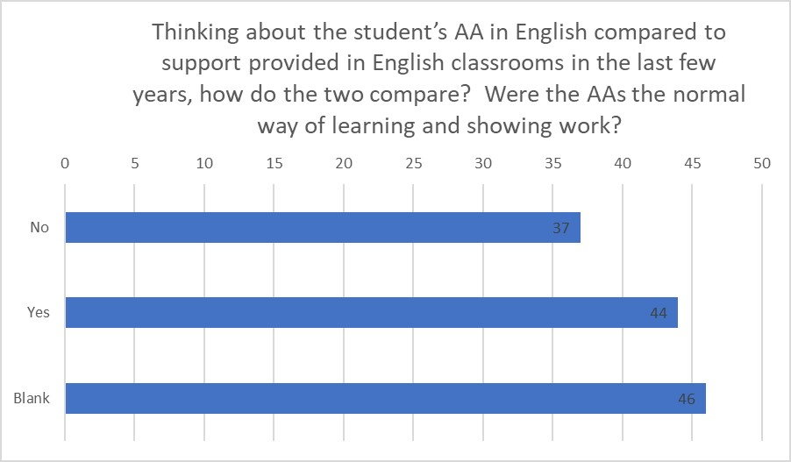

Parent comments on this question:
“Student says no, everyone is different, so time to become used to an identified reader and scribe would have been beneficial.”
“Mostly due to later diagnosis.”
“We encouraged her to practice typing.”
“Used Google Docs in classroom but expected to use Microsoft Word in exam.”
“Only in prelims.”
“Was left to the last 3 weeks prior to the exam. Was only able to have four practice sessions/tests with a scribe prior to the exam in those 3 weeks. None at all prior to this.”
“Only in the examination year – scribe”
“Perhaps could have had more practice. The only practice was in prelim exams – Use of ICT with text-reading software.”
“I am not aware of any practice at all.”

In 2021, John Swinney pledged that every pupil in Scotland would have a personal digital device by the end of the current Scottish parliament.
You might think that the roll-out of 1-1 technology in schools would have meant by 2023 that each pupil would be comfortable using their own device to support reading and writing difficulties and could then use their own device in an exam. CALLScotland do wonders for the country in providing the skilled knowledge and understanding of technological support for learning and a recent document https://www.callscotland.org.uk/blog/where-are-we-with-11-digital-technology/ presents a picture of where Scotland is across the local authorities. However, Local Authorities have not always consulted before purchasing and it turn out that currently some technology cannot be used to sit SQA exams! Hence pupils having to learn, in a couple of weeks or perhaps less, how to support themselves on a different type of computer!

Everything about exams is going to change in Scotland in the next few years. Could all the decision-makers please just keep in touch with CALLScotland?

These difficulties aside, it is excellent to see that every year more students are being supported by technology as opposed to a human being. Technology will continue to be their support after school, for private study, for work and for a full social/personal life and therefore schools need to start pupils using that early.

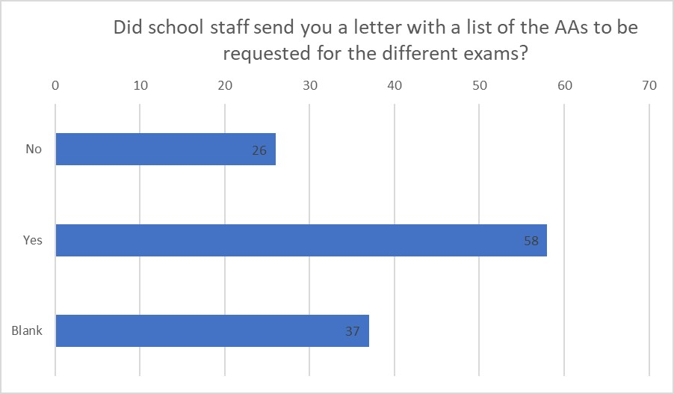

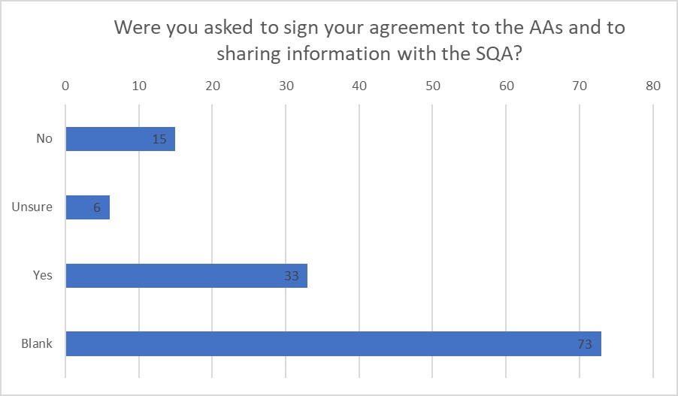

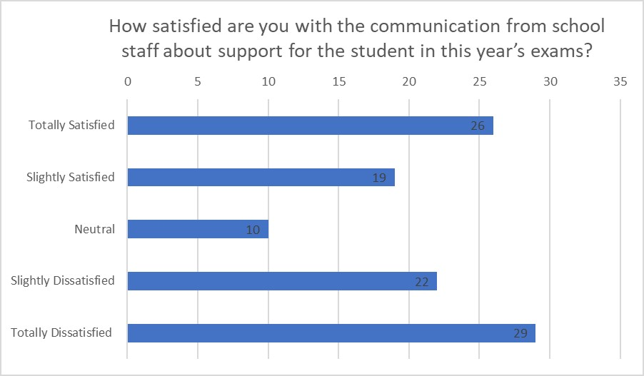

It is an enormous task arranging AAs for all pupils who need them in all their subjects with appropriate input from subject specialists and one which has grown, year on year. It is understandable that sending parents a “consent form” to have their final agreement, sign and send back promptly, may seem a step beyond possible! However, to consider parents as the important stakeholders they are in the outcomes of students, it is important to continue to include parents alongside their young person to the end of the AA journey in schools.
I want to finish by showing appreciation for the huge amount of extremely hard work carried out by staff in support teams in schools throughout Scotland every year. I hope I have made clear that support for pupils starts in the classroom and every teacher is a “support” teacher. All those “support” teachers need support to do their job well and to grow and develop where required and this has to come from their senior management, their Council employers, their Unions, and our country’s universities and politicians and all of them should be answerable to the young people who will, or will not, be able to become Scotland’s future doctors, joiners, carers, teachers, mechanics, chefs, administrators, etc.
* * * * * *

SQA (Scottish Qualifications Authority) Exam Support Survey 2023
This is a survey for Parents with a dyslexic student who has undertaken SQA Exams (Nat 5, Higher, Advanced Higher) at school in April/May 2023.
1 survey per student – to be completed by parent/carer, ideally alongside the student. If you have more than one student, please complete a separate survey form for each.
The purpose of the survey is not to challenge individual schools or teachers. I would like a wider picture of the needs of parents to learn more about support in secondary school and exams. Please be assured that no personal information such as names of individuals or schools will be divulged. Vivien Clarke
The survey was closed at the end of August 2023.

- Level of qualifications taken in 2023, Nat 5, Higher, Advanced Higher

- How many years/months has the student attended this school?

Please tick the closest response
From start of S1 Around 2 years 1 year or less

- Have you ever received a written statement that your son/daughter has dyslexia and requires some support for learning?
Yes/no
Did this come from primary school, secondary school, private assessment
Comment box

- Tick the challenges you are aware of for this student in tests/exams
reading
writing
memory (e.g. for mental arithmetic)
speed of work
concentration

- Did this student have a support plan describing support for learning which was made available to all the subject teachers?
Yes/No/Don’t know
Yes opens a further question – was this plan ever reviewed?
Yes/No
Yes opens a further question – were parents involved?
Yes/No
Comment box

- To what extent do you agree with these statements:
This student’s teachers fully considered his/her challenges in the lead up to the 2023 exams.
Are you satisfied with the communication from school staff about support for the student in this year’s exams? (Comment)

- Did the student have Assessment Arrangements (AAs) in any examinations? (e.g. Extra Time, Use of a Computer, Digital Papers, Text-reading software, Numerical support in Mathematics) Yes/ No
End of Questionnaire if No

- English

- Did the student sit an English Qualification this year?
(b) Did he/she have any Assessment Arrangements? – tick all those which apply:
None
Adapted question papers
Extra time
Use of ICT or Digital Question Papers
Prompter
Reader
Scribe
Separate accommodation
Supervised breaks
Referral of the candidate’s scripts to the principal assessor
Transcription with correction of spelling and punctuation
Transcription without correction

c) Thinking about the student’s Assessment Arrangements in English compared to support provided in English classrooms in the last few years, how do the two compare? Were the AAs the normal way of learning and showing work? Tick one- Yes/No

d) Did the student have enough practice of using the AAs? Tick one- Yes/No
Comment box

- Maths
- Did the student sit a Maths qualification this year?
No is end of question
(b) Did they have any AAs – tick all those which apply:
None
Adapted question papers
Extra time
Numerical support in mathematics assessments*
Use of ICT or Digital Question Papers
Prompter
Reader
Separate accommodation
Supervised breaks
*This AA offers use of a calculator, a number line or tables square
(c) Thinking about the student’s Assessment Arrangements in Maths compared to support provided in Maths classrooms in the last few years, how do the two compare? Were the AAs the normal way of learning and showing work? Tick one- Yes/No
(d) Did the student have enough practice of using the AAs? Tick one- Yes/No
Comment box

- (a) Did the student use AAs in examinations for other subjects this year? Yes/No
End of Q if No.
(b) Name of one of these subjects (comment box) (c) tick all those which apply:
Adapted question papers
Extra time
Use of ICT or Digital Question Papers
Prompter
Reader
Scribe
Separate accommodation
Supervised breaks
Referral of the candidate’s scripts to the principal assessor
Transcription with correction of spelling and punctuation
Transcription without correction

(c ) Thinking about the student’s Assessment Arrangements in this subject compared to support provided in this subject’s classrooms in the last few years, how do the two compare? Please tick one – Normal way of learning and showing work, Enough practice, not enough practice
Comment box

- (a) Did the school staff send you a letter with a list of the Assessment Arrangements that were requested for the different examinations? (Yes, No, Unsure)
- were you asked to sign your agreement to the AAs and to sharing information with SQA and return? (Yes, No, Unsure)

* * *
List of Proposals
Proposal 1 For Education Scotland, Local Authorities, Independent Schools

Every pupil in Scotland who has been on a “dyslexia pathway”, whether in primary, secondary or private school, must have at least a summary report of the route taken and the conclusions made as to whether a pupil has a support need (dyslexia) or not.

Proposal 2 For Education Scotland, Inspectorate, Local Authorities, School Management

Subject teachers to be required to report on support used (or not) in class as part of existing reporting. Reporting on pupils with support needs without any mention of support provided (or not) raises more questions for parents than it answers.

Proposal 3 For School Management

Support reviews to be carried out annually with a student and a parent/carer plus supporter if wished. The parent/carer could be on a link/phone if unable to attend.
Even at 16, students are still very vulnerable to peer pressure. They do not want to seem to be different, weaker or less intelligent. They may not fully comprehend the difference qualifications may make to the rest of their lives and they really should have an advocate. Asking parents to comment after the meeting is very different from including parents as equal partners in the discussion.

Proposal 4 For SQA
SQA must urgently look again at the wording of Numerical Support in Maths. This should be done with both experienced maths teachers and specialists in dyslexia and dyscalculia. The re-written descriptor must make it clear that some dyslexic pupils do have difficulties with maths within their dyslexia so that SQA centres can request Numerical Support for the reason they are dyslexic. Alternatively, a new “reason” could be added, for example “Memory Difficulties affecting Maths”.

Proposal 5 For Education Scotland, Local Authorities, secondary maths teachers
Teaching and learning in the high school classroom should incorporate both practice with and without a calculator for work which will crop up in the Non-Calculator Paper to allow pupils with specific memory difficulties to progress to Nat 5. Teacher observations could record which pupils can work more successfully at a suitable pace with a calculator. Their observations would provide the evidence for use of the AA and become a student’s “normal way of learning and showing work”.

Proposal 6 For SQA presenting centre managers/SQA
Ensure all pupils supported in exams for reason of dyslexia have had a short report declaring that the school considered them to be dyslexic. Then make it clear on the “consent” letter (if SQA have not changed their template) that parents are being asked for permission to share both AA information and disability/learning difficulty information with SQA.

