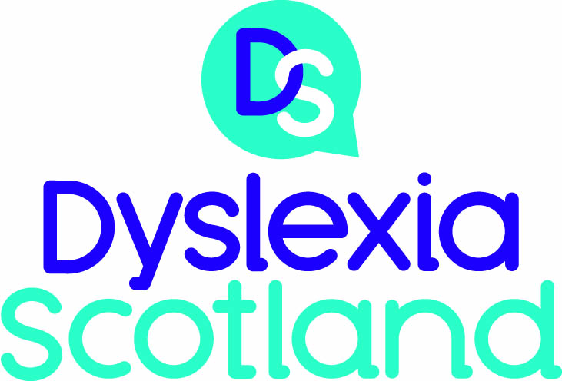

DYSLEXIA SCOTLAND
(A Company Limited by Guarantee)
SUMMARY FINANCIAL REPORT
FOR THE YEAR ENDED 31 MARCH 2022

The full Report and Financial Statements, including Company information, Directors’ Report, Report of the Auditors and Statement of Financial Activities, is available as a separate document.
This document provides a summary of the Financial Report under the following headings:
- Introduction
- Summary of Results
- Sources of Income
- Expenditure
- Balance Sheet
- Funding sources
- Appendix One - Statement of Financial Activities
- Appendix Two - Balance Sheet

Introduction
- The financial statements reflect:
(a) The Net Movement in Funds over the reporting period i.e. the difference between Income and Expenditure (see Appendix One - Statement of Financial Activities); and
(b) The Net Assets of the charity after allowing for all known liabilities (see Appendix Two - Balance Sheet)
Summary of Results
- Net Movement in Funds over the period to 31/03/22 resulted in a surplus of £36,937, i.e. income exceeded expenditure by this amount (a deficit of £19,666 was recorded for the corresponding period to 31/03/21).
- As a result of the above surplus, Net Assets increased to £519,782 as at 31/03/22 (£482,845 as at 31/03/21).
Sources of Income (See Appendix One)
- Total income for the year was £524,433 (£449,077 in 2021), an increase of £75,356 over the period.
- Donations and legacies totalled £493,641 (£418,132 in 2021), an increase of £75,509 over the period. This includes donations and gifts, grant income and donated goods and services.
- Donations and gifts were £74,039, an increase of £32,060 compared to 2021. The largest single donation during the year was £50,000 which came from a legacy from the late Edmund Wright to help children struggling at school.
- Grant income totalled £419,602 (£351,104 in 2021), an increase of £68,498 over the period. There was a net increase in the grant from the Scottish government of £15,000 which represents the amount withheld in 2021 because of lower operating costs as a result of Covid. The main reason for the increase since last year is because of a generous donation from the Sean Connery family philanthropy towards our Tutor Bursary Fund which amounted to £60,000.

- Donated goods and services in 2021 amounted to £25,049 and represents the rent due for our head office, which The Robertson Trust waived during the Covid lockdown period. There was no such waiver in 2022.
- Income from charitable activities amounted to £29,481 (£28,634 in 2021), up by £847. The Education Conference was once again held online due to Covid. Membership fees were £12,060 and this is down by £2,164 compared to last year
- Investment Income of £1,311 (£2,311 in 2021) was received during the year, representing interest on bank deposits.
Expenditure (See Appendix One)
- Total expenditure in the period amounted to £487,496 (£468,743 in 2021) an increase of £18,753. Staff costs at £268,136 (£260,666 in 2021) remain the largest item of expenditure representing 55% of total costs.
- Premises and Office expenses amounted to £52,499 (£60,610 in 2021) and are the next highest costs for the organisation, representing 11% of total costs.
Balance sheet (See Appendix Two)
- The balance sheet as at 31 March 2022 shows Reserves of £519,782, an increase of £36,937 on the corresponding figure as at 31/03/21. The increase represents the surplus reported for the current period.
- Year-end cash balances totalled £520,426 (£528,381 at 31/03/21). The cash balances held at the year–end are considered to be satisfactory and, in the context of the continued support of our major funders, capable of sustaining the organisation for the 2023/24 financial period and beyond.
Funding sources
- We are pleased to advise that our core activities continue to be funded by the Scottish Government Learning Directorate and the Scottish Government/Corra Foundation through the Children and Young People’s Early Intervention Fund/Adult Learning and Empowering Communities Fund to the extent of £250,000 in total.
- The Chief Executive position is funded by Dr. Walter Scott.
- The Sean Connery family contributed £60,000 in 2022 towards our Tutor Bursary Fund.
- We will continue to seek replacement of funding lines as they expire.
- 2022 Income from Charitable Activities amounted to £29,481 (£28,634 in 2021), an increase of £847 over the period. The largest contributors to the 2022 total were Membership fees £12,060 (£14,224 in 2021), Conference Fees £8,061 (£8,686 in 2021), and Training Income £6,995 (£3,502 in 2021)
- Given the financial implications of Covid-19 and beyond, the Board constantly review income and expenditure to ensure we continue to meet the increasing demand for support and services for children, young people and adults with dyslexia.

APPENDIX ONE – STATEMENT OF FINANCIAL ACTIVITIES
For the Year Ended 31 March 2022

Dyslexia Scotland
Statement of Financial Activities
Including Income and Expenditure Account
For the year ending 31st March 2022

The statement of financial activities includes all gains and losses recognised in the year.
All income and expenditure derive from continued activities.
The statement of financial activities also complies with the requirements for an income and expenditure account under the Companies Act 2006.

APPENDIX TWO – BALANCE SHEET as at 31 March 2022
Balance Sheet
As at 31st March 2022

These financial statements have been prepared in accordance with the provisions to companies subject to the small companies regime.
The financial statements were approved by the Trustees on 31st August 2022.

Mr D. Shaw
Trustee
Company registration number SC153321

